**Web Designing Assignment**

**Module (HTML5) – 3**

**Que 1)What are the new tags added in HTML5?**

**Ans:**HTML 5 is new version of HTML.in HTML 5 many new tags are added these tags are generally supported by all major browser

The commonly used new HTML5 tags are <figure>, <article>, <aside><header>, <main>,<footer>, <nav>, <section>, <mark>

1)Article: Used to specify a blog, a magazine or a newspaper article or any other independent piece of content in a document.

2)Aside: Used to indicate that the specified article is somehow related to the rest of the document.

3)figure: Used to specify a self-contained content like photos, diagrams etc.

4)Header: Used to specify a header for a section.

5)Footer: Used to specify a footer for a section.

6)main: Used to specify the main content of a document.

7)nav: Used to specify a navigation link in an HTML document.

8)Section: Used to specify a section in an HTML document.

9)Mark:Used to mark of highlighted content

**------------------------------------------------------------------------------------------------------------------------------------------**

**Que. 2) How to embed audio and video in a webpage?**

**Ans:**

Audio tag: The <audio> tag is used to embed sound content in a document, such as music or other audio streams.

Video tag: The <video> tag is used to embed video content in a document, such as a movie clip or other video streams.

**Example Code:**

<!DOCTYPE html>

<html lang="en">

<head>

<meta charset="UTF-8">

<meta http-equiv="X-UA-Compatible" content="IE=edge">

<meta name="viewport" content="width=device-width, initial-scale=1.0">

<title>Document</title>

</head>

<body>

<audio src="Shiva Tandava Stotram __ Original Powerful .mp3.crdownload" controls loop></audio>

<video src="flower.webm" controls loop></video>

</body>

</html>

**Output:**

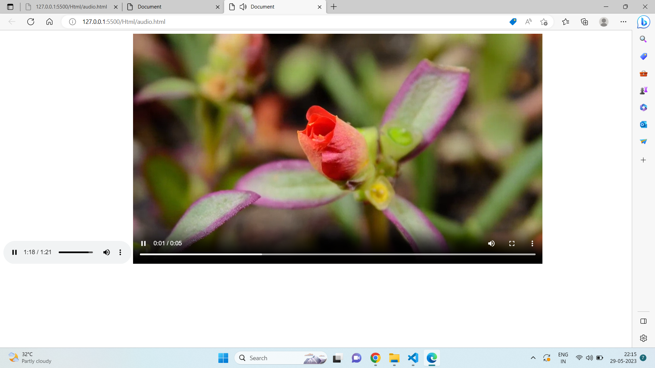

---------------------------------------------------------------------------------------------------

**Que. 3) Semantic element in HTML5?**

**Ans:** In HTML there are some semantic elements that can be used to define different parts of a web page:

* <article>
* <aside>
* <details>
* <figcaption>
* <figure>
* <footer>
* <header>
* <main>
* <mark>
* <nav>
* <section>
* <summary>
* <time>

**Example Code:**

<!DOCTYPE html>

<html lang="en">

<head>

<meta charset="UTF-8">

<meta http-equiv="X-UA-Compatible" content="IE=edge">

<meta name="viewport" content="width=device-width, initial-scale=1.0">

<title>Document</title>

<style>

aside {

width: 30%;

padding-left: 15px;

margin-left: 15px;

float: right;

font-style: italic;

background-color: lightgray;

}

</style>

</head>

<body>

<section>

<h1>Lorem</h1>

<p>Lorem ipsum dolor sit amet consectetur, adipisicing elit. Saepe quo libero aliquid, in vero ducimus quaerat

eaque pariatur id quibusdam! Est voluptatibus, tempore voluptate quasi nobis iste sint esse neque.</p>

</section>

<section>

<h1>Lorem</h1>

<p>Lorem ipsum dolor sit amet consectetur, adipisicing elit. Saepe quo libero aliquid, in vero ducimus quaerat

eaque pariatur id quibusdam! Est voluptatibus, tempore voluptate quasi nobis iste sint esse neque.</p>

</section>

<article>

<header>

<h1>Lorem</h1>

</header>

<p>Lorem ipsum dolor sit amet consectetur, adipisicing elit. Saepe quo libero aliquid, in vero ducimus quaerat

eaque pariatur id quibusdam! Est voluptatibus, tempore voluptate quasi nobis iste sint esse neque.</p>

</article>

<footer>

<p>Lorem ipsum dolor sit amet consectetur, adipisicing elit. Saepe quo libero aliquid, in vero ducimus quaerat eaque pariatur id quibusdam! Est voluptatibus, tempore voluptate quasi nobis iste sint esse neque.</p>

</footer>

<nav>

<a href="/html/">HTML</a>

<a href="/css/">CSS</a>

<a href="/js/">JavaScript</a>

<a href="/jquery/">jQuery</a>

</nav>

<aside>

<p>Lorem ipsum dolor sit amet consectetur, adipisicing elit. Saepe quo libero aliquid, in vero ducimus quaerat

eaque pariatur id quibusdam! Est voluptatibus, tempore voluptate quasi nobis iste sint esse neque.</p>

</aside>

</body>

</html>

**Output:**

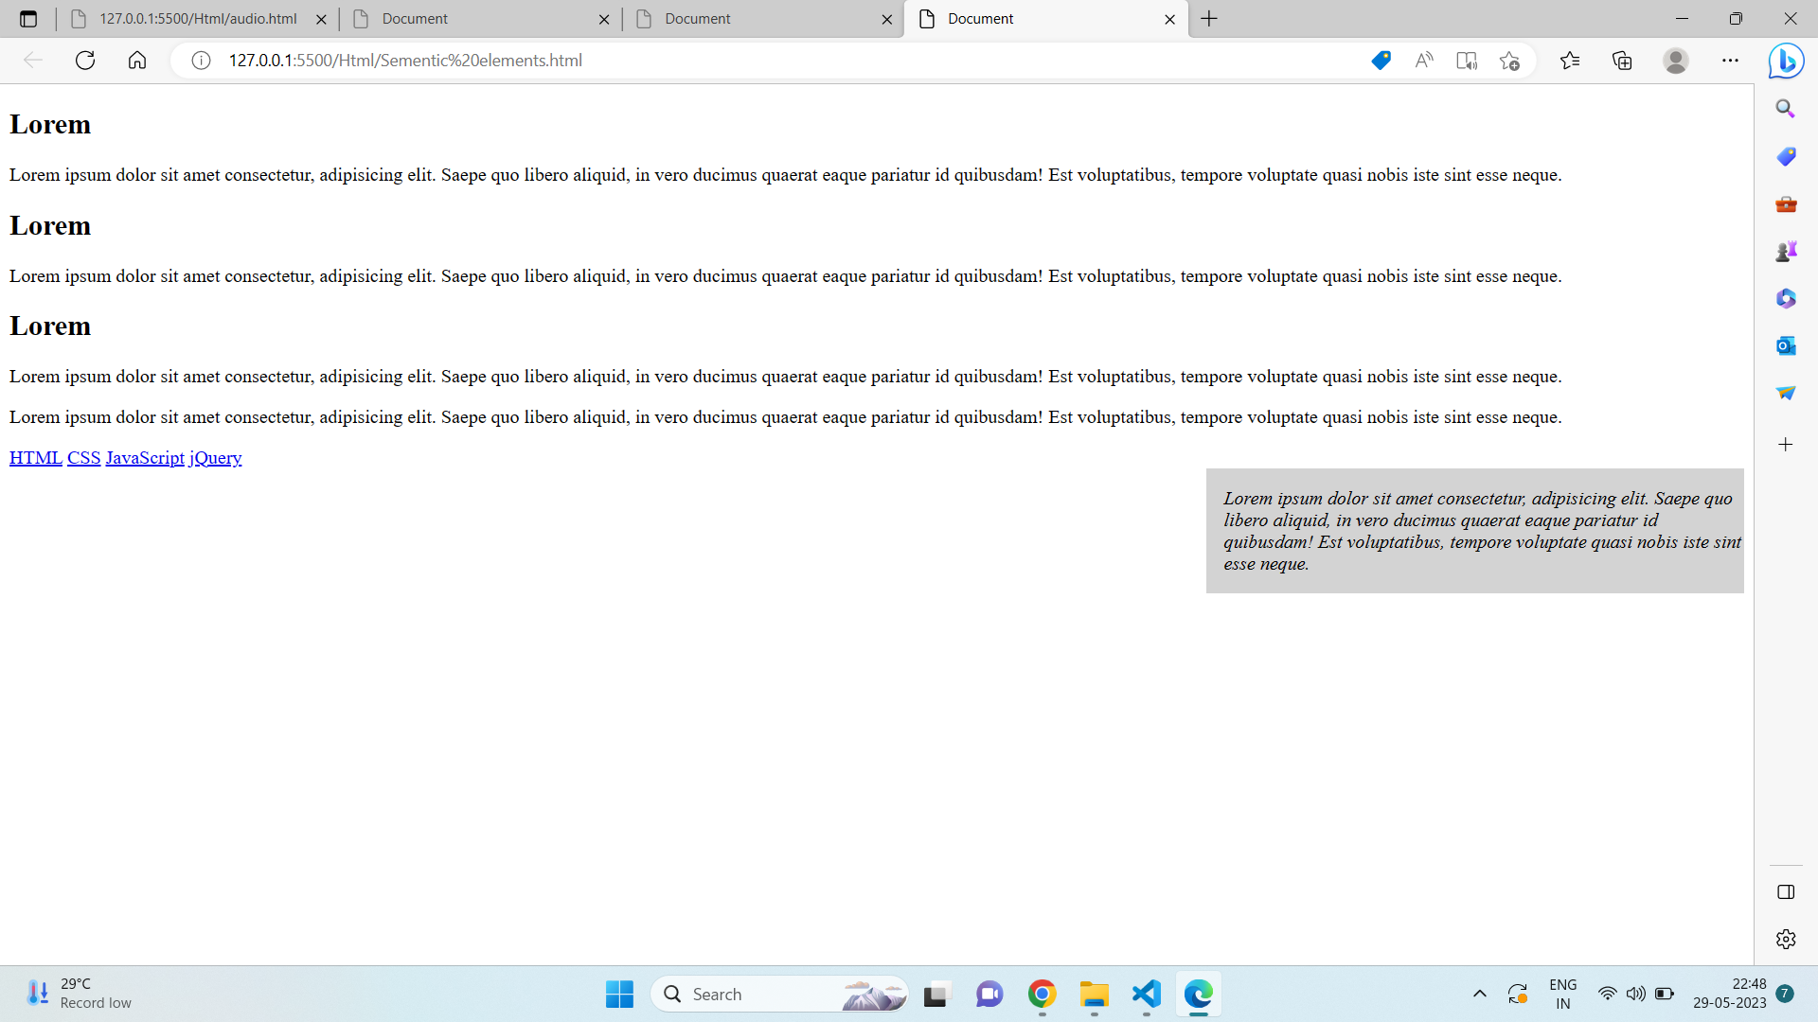

**------------------------------------------------------------------------------------------------------------------------------------------**

**Que. 4) Canvas and SVG tags?**

**Ans:Canvas:** The HTML <canvas> element is used to draw graphics, on the fly, via JavaScript.

The <canvas> element is only a container for graphics. You must use JavaScript to actually draw the graphics.

Canvas has several methods for drawing paths, boxes, circles, text, and adding images.

**Example Code:**

<!DOCTYPE html>

<html lang="en">

<head>

<meta charset="UTF-8">

<meta http-equiv="X-UA-Compatible" content="IE=edge">

<meta name="viewport" content="width=device-width, initial-scale=1.0">

<title>Document</title>

</head>

<body>

<canvas id="myCanvas" width="200" height="100" style="border:1px solid #000000;">

</canvas>

</body>

</html>

**Output:**

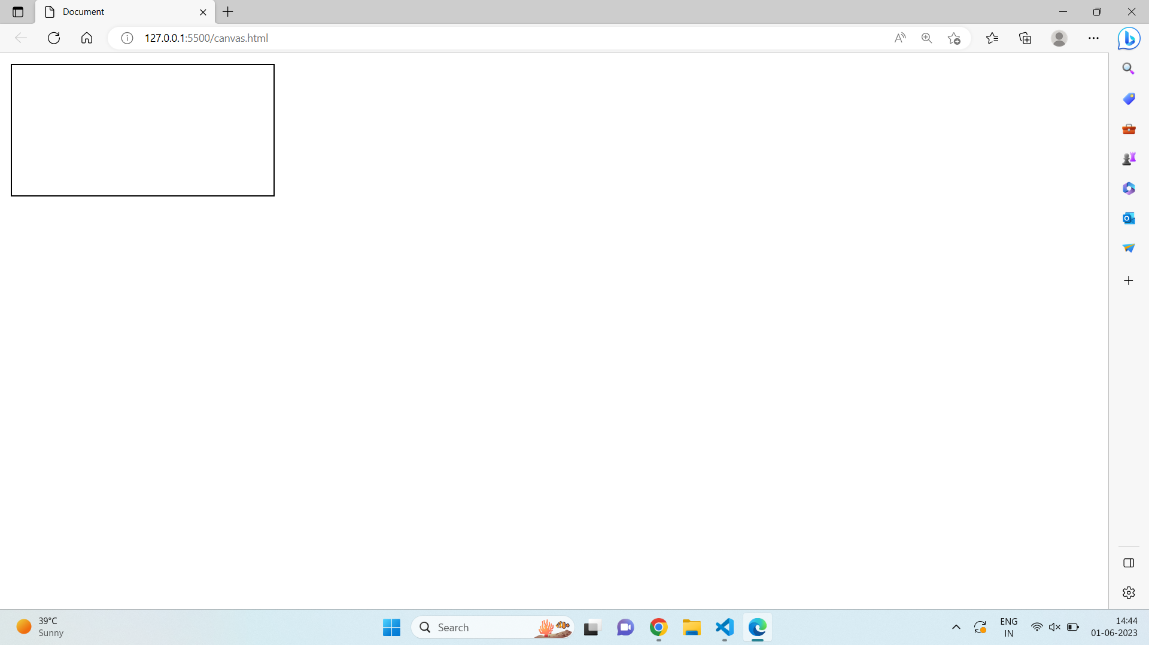

**SVG:**SVG stands for Scalable Vector Graphics,

SVG is used to define graphics for the Web

SVG is a W3C recommendation

The HTML <svg> element is a container for SVG graphics.

SVG has several methods for drawing paths, boxes, circles, text, and graphic images.

**Example Code:**

<!DOCTYPE html>

<html lang="en">

<head>

<meta charset="UTF-8">

<meta http-equiv="X-UA-Compatible" content="IE=edge">

<meta name="viewport" content="width=device-width, initial-scale=1.0">

<title>Document</title>

</head>

<body>

<svg width="100" height="100">

<circle cx="50" cy="50" r="40"

stroke="green" stroke-width="4" fill="yellow" />

</svg>

</body>

</html>

**Output:**

